Make a
Python
Package
for
Easy App Making
by
Christopher Andrew Topalian

All Rights Reserved
Copyright 2000-2024
Dedicated
to
God the Father

How to Make a Python Package (Library)

Let's make a library of functions for us to use in all of our projects, which we will install system wide on our computer. Later, we can even choose to upload our package to the internet and share it with the world.

By making a package of functions we can update our package anytime that we want and all of our projects will utilize the same updated library!

This makes programming much easier, because we only have to make the library one time, instead of over and over again.

This allows us to be much more productive, because the package can easily be imported after it has been installed system wide using pip install .

How to Create a Python Package
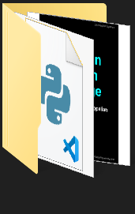
* We create a folder, named mylib

* In mylib folder we make another folder named mylib
mylib
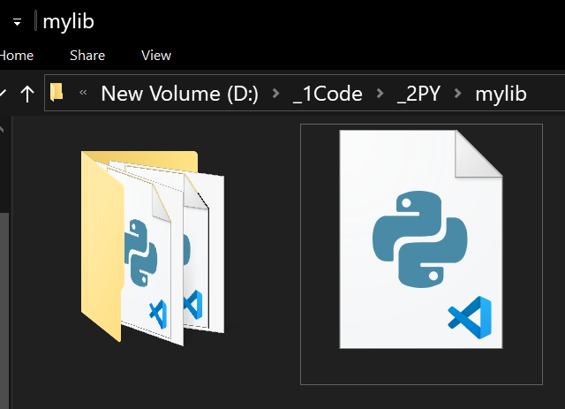

mylib
setup.py
* In the main mylib folder, we place setup.py

setup.py is used to Install our Package

We create a setup.py file, which defines our package and its metadata. This file is essential for distributing and installing our library across projects.

First, we make a new text file in VSCode Editor
and type the script that we see on the next page and save it as setup.py

NEXT PAGE SHOWS setup.py

# setup.py

from setuptools import setup, find_packages

setup(
name = 'mylib',
version = '0.1',
author = 'Christopher Andrew Topalian',
packages = find_packages(),
)

####

# Dedicated to God the Father
# All Rights Reserved Christopher Andrew Topalian Copyright 2000-2024
# https://github.com/ChristopherTopalian
# https://github.com/ChristopherAndrewTopalian
# https://sites.google.com/view/CollegeOfScripting

* In the second mylib folder, we place 3 files:
__init__.py
multiply.py
divide.py
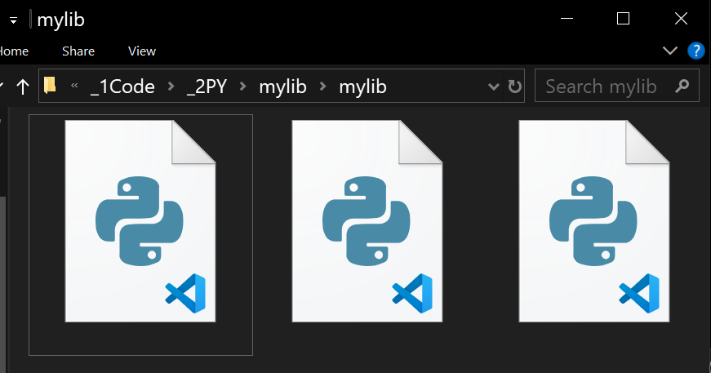

__init__.py
multiply.py
divide.py

The first file is named __init__.py
which has two underscores before and after.

We write two underscores together __ and then the word init and then two more underscores.

We save our file as __init__.py

# __init__.py

from .multiply import multiply
from .divide import divide

####

# Dedicated to God the Father
# All Rights Reserved Christopher Andrew Topalian Copyright 2000-2024
# https://github.com/ChristopherTopalian
# https://github.com/ChristopherAndrewTopalian
# https://sites.google.com/view/CollegeOfScripting

Here are the python library function files that we will add to our mylib package.

__init__.py
multiply.py
divide.py

We place multiply.py and divide.py
inside of this second mylib folder.

Thus, the two functions we are adding to our library are: multiply.py and divide.py

On the next page, we see the python function script that we save as multiply.py

NEXT PAGE SHOWS multiply.py
# multiply.py

def multiply(a, b):
return a * b

##

if __name__ == "__main__":
print(multiply(4, 4))
input('')

####

# Dedicated to God the Father
# All Rights Reserved Christopher Andrew Topalian Copyright 2000-2024
# https://github.com/ChristopherTopalian
# https://github.com/ChristopherAndrewTopalian
# https://sites.google.com/view/CollegeOfScripting

On the next page, we see the python function script that we save as divide.py

NEXT PAGE SHOWS divide.py
# divide.py

def divide(a, b):
return a / b

##

if __name__ == "__main__":
print(divide(10, 2))
input('')

####

# Dedicated to God the Father
# All Rights Reserved Christopher Andrew Topalian Copyright 2000-2024
# https://github.com/ChristopherTopalian
# https://github.com/ChristopherAndrewTopalian
# https://sites.google.com/view/CollegeOfScripting

How to Install Our Package Computer Wide

We type cmd into the mylib main folder address bar and press Enter
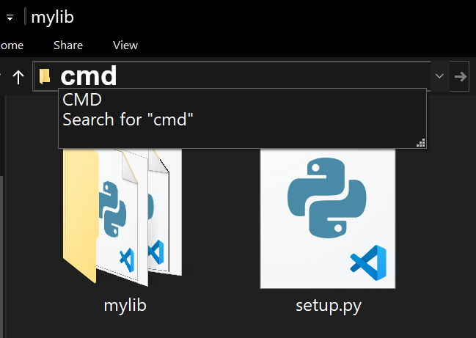

We type in the Command prompt:
pip install .

press Enter

This installs our Package system wide.

Now, we can import our package from anywhere in our Python environment on our computer.

Now, let's make a new script and import and use the functions from our package that we have created and installed worldwide on our computer system.

We make a new script in VSCode and save it as, usesOurPackage.py

NEXT PAGE SHOWS usesOurPackage.py
# usesOurPackage.py

from mylib import multiply, divide

multiplied = multiply(4, 4)
print(multiplied)

divided = divide(10, 2)
print(divided)

####

# Dedicated to God the Father
# All Rights Reserved Christopher Andrew Topalian Copyright 2000-2024
# https://github.com/ChristopherTopalian
# https://github.com/ChristopherAndrewTopalian
# https://sites.google.com/view/CollegeOfScripting

Updating Our Package

When we make changes and want to update our package with new functions or changes to our existing functions:

We Don't Update the package using:
pip install -e .

press Enter

Instead, it is easier to uninstall the package and then install it again to avoid conflicts.

We open the system wide command prompt and type:
pip uninstall mylib

press Enter

This uninstalls the mylib package from the system.

We repeat the install process as before:

We type cmd into the mylib main folder address bar and press Enter

We type in the Command prompt:
pip install .

press Enter

This again installs our Package system wide. Now, any changes that we have made, such as any additional functions included, are now available in our library of functions.

Now, we can import our package from anywhere in our Python environment on our computer and use the functions from our package in any script that we are making :-)

How to Paste Code from a PDF
that has Junk Characters.
How to Paste Code from a PDF
that has Junk Characters.
When we paste from a pdf into VSCode,
it might look like this:
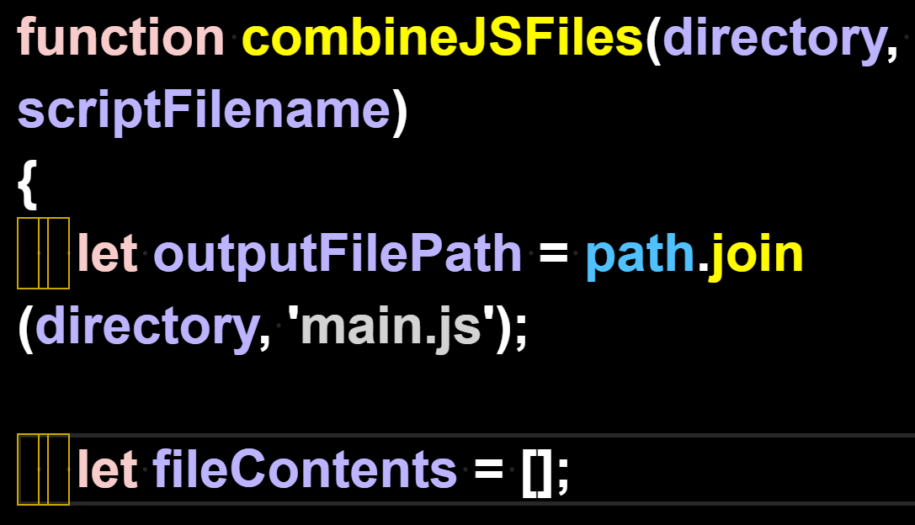

We can't leave those junk characters in the code, so we remove them with find/replace.

We Find 1 of the spaces.
We Replace All with the 1 space that we typed. This gets rid of the junk characters in the code.

We highlight 1 space with our mouse arrow:
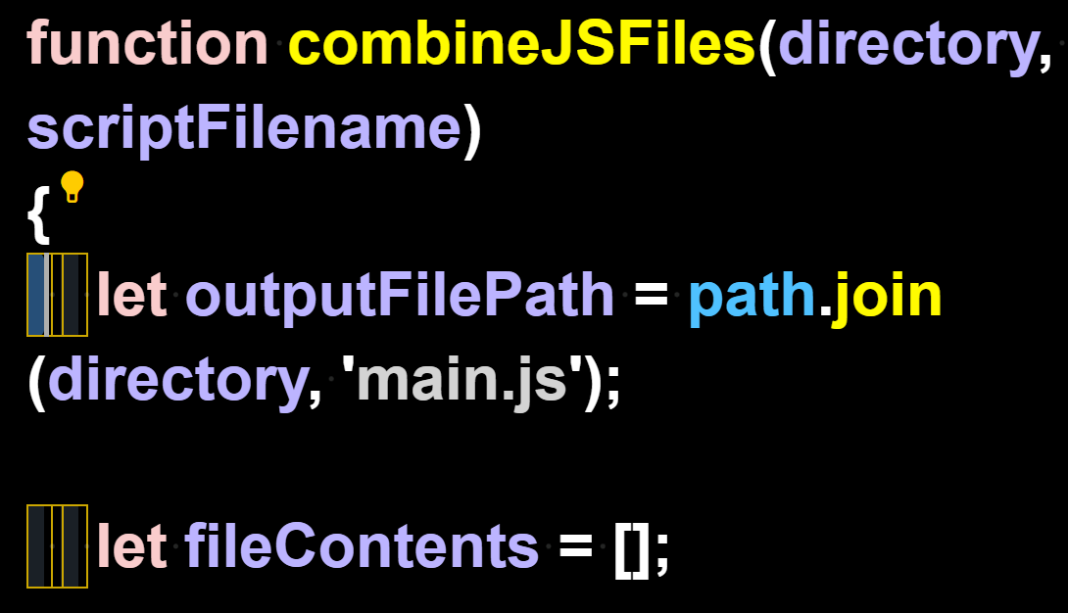
We press Control + H to open the Find/Replace feature and Replace All with our own Space
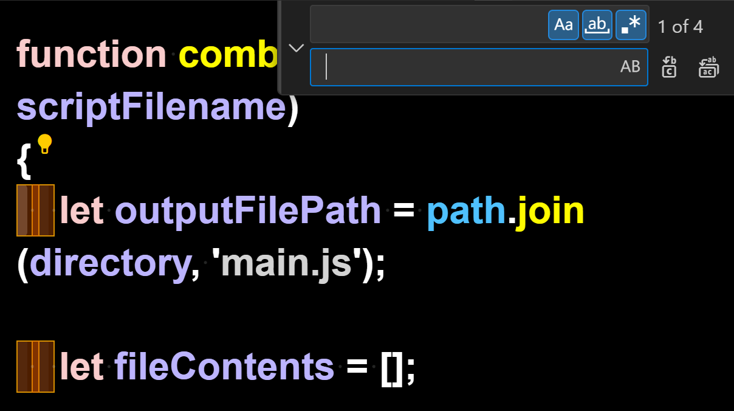

Here we see that the Find/Replace All has replaced the junk characters

with our working spaces instead:
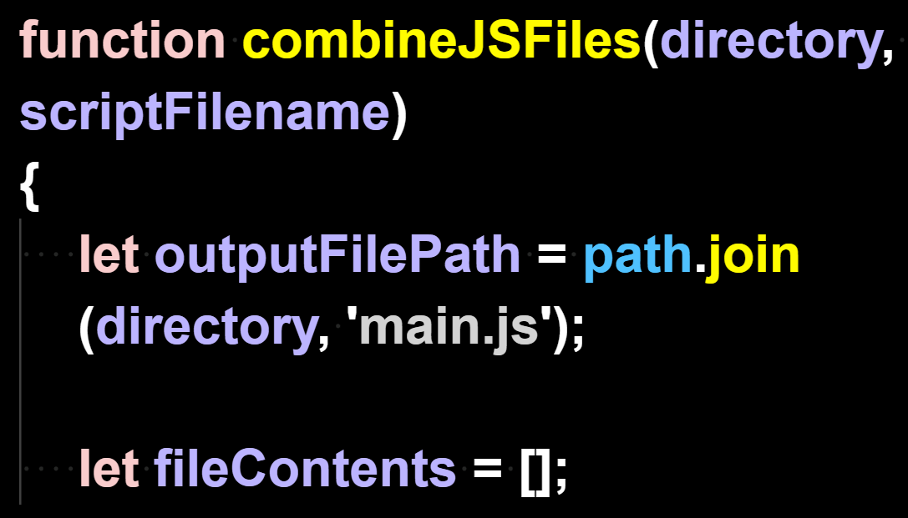

Now that the code
has no junk characters,
it can run.

True Artificial Intelligence System
Tautology
1111
Contra-
-diction
0000
XOR
0110
XNOR
1001
AND
0001
NAND
1110
OR
0111
NOR
1000
MI
1101
MNI
0010
LP
0011
LC
1100
RP
0101
RC
1010
CI
1011
CNI
0100
16-Gon
For More Tutorials:

GitHub.com/ChristopherTopalian
GitHub.com/ChristopherAndrewTopalian
Sites.google.com/view/CollegeOfScripting
CollegeOfScripting.weebly.com
CollegeOfScripting.wordpress.com
Youtube.com/ScriptingCollege
Twitter.com/CollegeOfScript
Rumble.com/user/CollegeOfScripting

Dedicated to God the Father

This book is created by the
College of Scripting Music & Science.
Always remember, that each time you write a script with a pencil and paper, it becomes imprinted so deeply in memory that the material and methods are learned extremely well.

When you Type the scripts, the same is true. The more you type and write out the scripts by keyboard or pencil and paper, the more you will learn programming!

Write and Type every example that you find.
Keep all of your scripts organized.
Every script that you create increases your programming abilities.
SEEING CODE, is one thing,
but WRITING CODE is another.
Write it, Type it, Speak it, See it, Dream it.

CollegeOfScripting.weebly.com

